REVENUE TEARDOWN
· MONETIZATION STRATEGY ·
2025-26

SUBJECT·CRED·
(DREAMPLUG TECHNOLOGIES)
CRED'S
₹865 Cr
PROBLEM
India's most engaged fintech user base — and one of its most structurally under-monetized

DOCUMENT TYPE | Strategic Monetization Case Study — Consulting Grade
SCOPE | Engagement-to-Revenue System Redesign
CORE THESIS | CRED's engagement system and monetization system are structurally disconnected — and the gap is compounding
ESTIMATED OPPORTUNITY | ₹265 Cr – ₹865 Cr Additional ARR from Existing Users

CONSULTING-GRADE · PORTFOLIO ASSET · CONFIDENTIAL

OPENING
The System Is Optimized for Habit Formation. Not Revenue.
CRED has built something genuinely difficult: a highly engaged, premium fintech user base in a market that rewards volume over value. 13 million monthly active users. ~20 app sessions per month. 88% monthly retention. These are not ordinary numbers — they are metrics that rival the best consumer platforms globally.

None of that is the problem.

The problem is that CRED has engineered one of the strongest engagement systems in fintech — and attached it to one of the weakest monetization engines. Users pay their bills. They earn their rewards. They return next month. ARPU stays anchored at ~₹2,000 — from a user base that sits in the top 1% of Indian income earners.

This is not a product problem. This is not a demand problem. This is a structural architecture problem: the system converts engagement into habit reliably, and then stops. No next action triggered. No conversion layer. No system logic connecting what users do to what CRED earns.

CRED's engagement is engineered. Its monetization is accidental. That is not a minor optimization gap — it is the entire growth problem.

02 / CONTEXT
A Premium User Base. A Modest Revenue Capture.
₹2,735 Cr  FY25 Revenue | 13M  Monthly Active Users | ~₹2,000  ARPU (Annual) | 88%  Monthly Retention | ~20  App Sessions / Month

CRED's acquisition model is precision-engineered: CIBIL ≥750 as entry threshold, targeting ~25–30 million affluent credit-card holders in India. This is not a broad consumer app. It is a premium platform serving users with high income, strong credit discipline, and measurable spending power.

FY25 revenue grew 16% YoY to ₹2,735 Cr. Transacting users grew ~34% in FY24 while CAC dropped ~40%. On surface metrics, this reads as healthy PLG execution.

Look one layer deeper: 55% of active users remain on a single product. Only 12% use the financial dashboard. ARPU of ₹2,000 — from users capable of spending multiples of that annually — is not a monetization success. It is a monetization baseline masquerading as one.

◈ NON-OBVIOUS INSIGHT #1: THE CIBIL GATE CREATES A MONETIZATION PARADOX
CRED's entry filter — designed to attract India's most creditworthy users — simultaneously creates its hardest monetization challenge. Users who qualify are financially disciplined by definition: they do not need unsolicited credit nudges, they are suspicious of generic financial product pushes, and they have optionality. Monetizing them requires earning trust before triggering transactions. CRED's current system skips this step entirely — it goes from habit to nothing, bypassing the trust-to-transaction bridge that premium monetization requires.

03 / REVENUE SYSTEM DIAGNOSIS
Where the System Works — And Where It Breaks
A system diagnosis requires first understanding what is working. The map below is not a list of failures — it is a cause-and-effect chain that reveals precisely where value creation stops translating into revenue capture.

FIGURE 01 · CRED REVENUE SYSTEM WITH MONETIZATION LEAKS
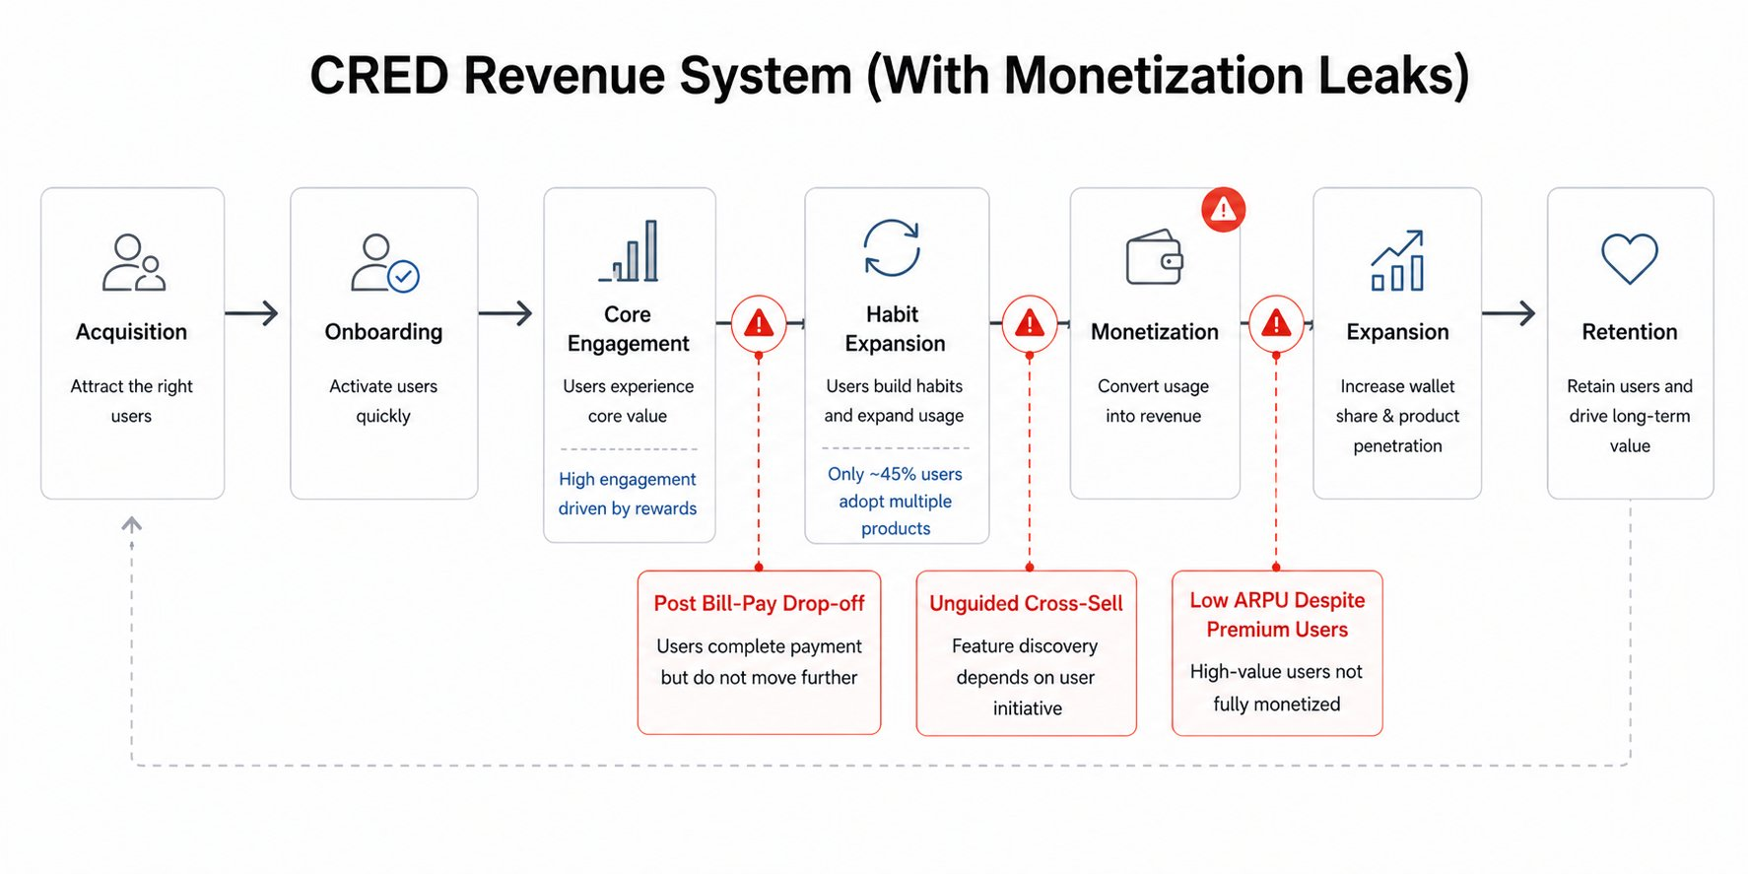
Strong acquisition and engagement — three discrete failure points before revenue is captured.
What Works
Acquisition is precision-engineered. The CIBIL ≥750 gate self-selects for financially disciplined, high-income users — reducing CAC, improving retention, and creating a brand premium that no mass-market competitor can replicate. Onboarding is frictionless. Core engagement — the bill-pay loop, gamified by CRED Coins, streaks, and status tiers — is one of the strongest habit engines in Indian fintech. ~14.4 payments per user per month, 88% retention. These are the numbers of a platform with genuine product-market fit.
Where It Breaks
The break is precise: it occurs at the transition between Core Engagement and Habit Expansion. After a user pays their bill, the system stops guiding them. No next action is triggered. No adjacent value is surfaced. The user exits a completed task with no system-level prompt toward higher-value behavior.

From that point, expansion is entirely user-initiated. 58% of users never move beyond bill-pay. 52% have no secondary feature adoption. The products exist — loans, UPI, RentPay, insurance, investments — but they exist as a catalogue, not a journey. Discovery is passive. Conversion is accidental. Revenue is capped.

FIGURE 02 · ENGAGEMENT VS. REVENUE OVER THE USER JOURNEY
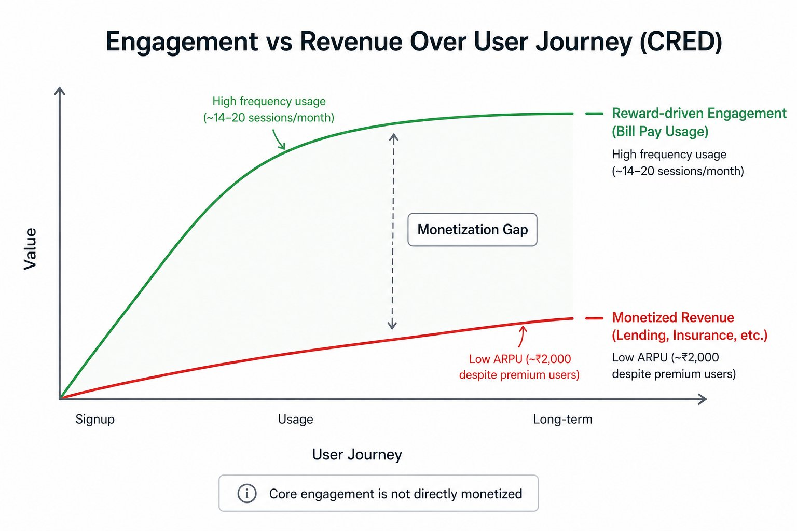
Engagement compounds strongly. Revenue capture remains flat. The gap between the two curves is the monetization opportunity.

CRED’s engagement system and monetization system are not connected. Engagement is engineered. Monetization is left to chance. This is a deliberate product choice — and it is costing ₹865 Cr/year.

04 / REVENUE LEAKS
Four System Failures. One Compounding Revenue Cap.
These are not product gaps or feature gaps. They are structural failures in the revenue architecture — each one reducing conversion of engagement into monetization, and together creating an ARPU ceiling that no amount of new user acquisition can break through.

01 | Engagement–Revenue Disconnect  CRED’s core engagement loop — bill pay, rewards, gamification — generates ~20 sessions/month and 88% retention. The core action generates minimal direct revenue. The engagement loop is optimized to bring users back, not to extract financial value from their return.  A high-engagement system without a monetization conversion layer is not an asset — it is a liability dressed as one. CAC is justified only if engagement eventually converts. Without the conversion layer, every retained user is a cost, not a revenue event.  The more CRED succeeds at habit formation without monetization, the worse its unit economics become. Infrastructure scales with engagement. Revenue does not follow.  Structural consequence: ARPU capped at ~₹2,000 despite premium users. High usage ≠ high revenue. The gap between these two numbers is the exact size of the architecture failure.

02 | Passive Expansion Architecture — The Core Leak  55% of users remain on 1–2 products. There is no guided journey, no embedded upsell trigger, no system logic that moves a user from bill payment to a contextually relevant financial product.  CRED’s own research confirms the failure explicitly: ‘users finish the main action but are not told what to do next.’ This is not user research — it is a confession that the product has no next-action architecture.  In a well-designed monetization system, expansion is a product responsibility. When it is left to users to discover, most never do — not because they lack intent, but because the friction of self-directed discovery exceeds the perceived benefit of exploration.  Structural consequence: Multi-product users generate 1.5–2x ARPU. With 55% of the active base stuck at single-product, the majority of CRED’s highest-quality users are systematically under-monetized.

03 | Under-Monetized Premium User Base  CRED’s users represent the top 1% of Indian credit-card holders by creditworthiness — high monthly card spends, strong repayment discipline, measurable investable surplus. ₹2,000 ARPU captures a fraction of the financial value this cohort represents.  This is not a willingness-to-pay problem. Premium users actively seek financial products. The gap is that CRED’s monetization system applies uniform extraction logic to a non-uniform user base — and the mismatch is structural.  The CIBIL filter was designed to create a premium user base worth more per user. The monetization system has not been designed to extract that premium. CRED is running a Rolls-Royce acquisition funnel into a mid-market monetization model.  Structural consequence: Massive untapped LTV. The CIBIL ≥750 gate — CRED’s most defensible competitive asset — is generating user quality that the revenue system cannot capture.

04 | Fragmented Product Ecosystem  CRED has built a meaningful portfolio — loans, UPI, RentPay, insurance (Garage), investments (Mint), e-commerce (Store). These are legitimate, revenue-generating products.  But product breadth without product connectivity is not a platform — it is a catalogue. Each product competes for independent user discovery instead of benefiting from system-level expansion logic. The result: low adoption of high-margin products despite a user base primed for them.  Only ~12% use the financial dashboard. This is not a feature awareness problem — it is a journey design problem. Users do not encounter adjacent products through natural usage paths. They encounter them only if they go looking.  Structural consequence: CRED built multiple revenue opportunities — but not the system to activate them. Every high-margin product sits behind a passive discovery wall.

◈ NON-OBVIOUS INSIGHT #2: THE REWARDS PROGRAMME IS ACTIVELY COMPETING WITH MONETIZATION
CRED Coins create a psychological substitution effect: users who earn coins on bill payment feel they are already receiving value from the platform. This satisfaction loop reduces perceived need for additional product engagement. The gamification that drives retention may be suppressing the dissatisfaction that typically motivates financial product adoption. CRED has built a system so effective at making users feel rewarded that it inadvertently reduces the urgency to transact further. The engagement engine and the monetization engine are not just disconnected — they may be pulling in opposite directions.

05 / STRUCTURAL PROBLEM
One Failure. Four Symptoms.
The four leaks above are not independent problems requiring four independent solutions. They are four visible expressions of a single systemic absence: no automated engagement-to-monetization conversion layer exists anywhere in the product architecture.

Strong Engagement
↓ No Guided Expansion
↓ Low Product Adoption
↓ Under-Monetized Premium Users
↓ Capped Revenue

CRED’s revenue problem is not demand, product, or users. It is the complete absence of a system that converts engagement into monetization — automatically, contextually, and at scale.

Every high-value behavioral signal — consistent bill payment, high monthly spend, frequent app returns — is a monetization opportunity. In the current architecture, these signals arrive, are logged, and then expire. No trigger fires. No product surfaces. No revenue event occurs.

This is the architecture gap. Everything else is a symptom of it.

◈ NON-OBVIOUS INSIGHT #3: CRED MAY BE DELIBERATELY DEFERRING MONETIZATION — AND APPROACHING A STRATEGIC INFLECTION POINT
CRED’s monetization restraint may not be purely architectural. Building India’s most premium fintech brand requires not spamming users with financial product pitches — CRED has historically treated monetization as subordinate to trust-building. This was strategically correct in the 0-to-10M user phase. It is strategically dangerous in the 10M-to-50M phase. The same restraint that built the brand is now creating a revenue architecture that cannot scale. The question CRED’s leadership must answer is not ‘how do we add monetization?’ but ‘how do we monetize without becoming what we built our brand against?’ That is a harder question — and the fixes that follow are designed to answer it.

06 / STRATEGIC RE-ARCHITECTURE
Four System-Level Fixes
These are not feature suggestions. They are structural changes to how CRED’s revenue system is designed — each targeting a specific failure point in the engagement-to-monetization chain. Each includes the execution logic required to make it real, not aspirational.

FIGURE 03 · CURRENT SYSTEM VS. IDEAL SYSTEM
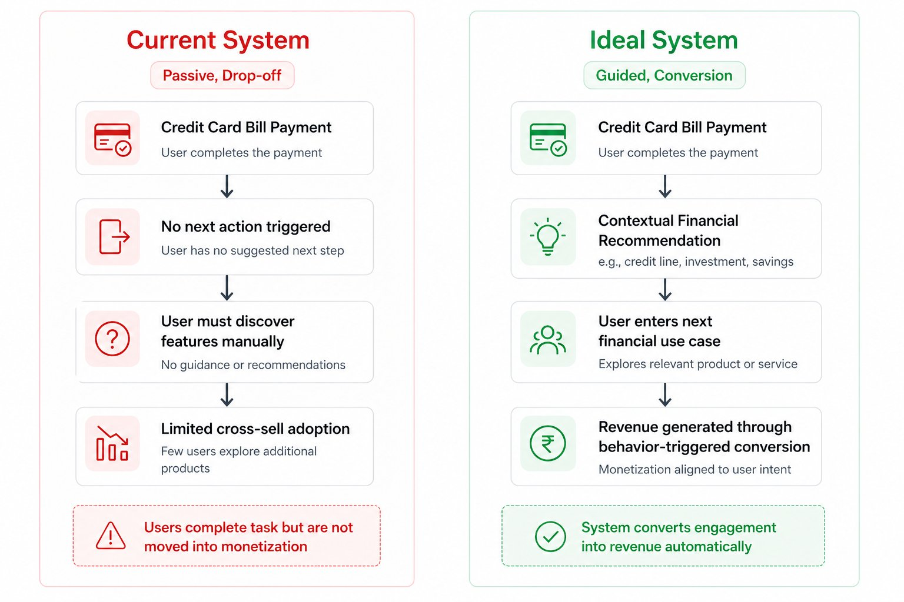
Current: passive drop-off after core action. Ideal: guided conversion layer that moves users into contextual monetization automatically.

01 Value-Linked Monetization Layers
SIGNAL | User pays ≥₹15,000 bill consecutively for 3+ months, or has ₹50,000+ in average monthly card spend — indicating income level and financial management capacity above the base threshold.
TRIGGER | Post-bill-pay confirmation screen (highest engagement moment in the session) triggers a contextually framed offer: credit line for liquidity management, investment product for idle surplus, or premium financial tool calibrated to their credit profile. Trigger fires within 2 seconds of payment confirmation.
UX GATE | One offer per session maximum. Premium visual presentation — never a banner or pop-up. Framed as ‘Your CRED profile qualifies you for…’ not ‘Upgrade now.’ Dismiss option always visible. System learns from dismissals and adjusts frequency and offer type accordingly.
REVENUE OUTCOME | Monetization fires at the moment of highest intent and lowest friction — immediately after a completed financial action. Conversion uplift: +10–20% on monetized actions. ARPU increase: +5–8%. Revenue potential: ₹130–220 Cr/year.

02 Guided Expansion Engine
SIGNAL | User completes bill pay. No secondary feature interaction in the current session. Session recency score indicates high-intent window (first 90 seconds post-payment).
TRIGGER | Engineered next-action layer activates: ‘Paid ₹X this month → your credit utilization is Y% → here’s how to optimize it.’ Or: ‘High spend detected this month → you’re eligible for a credit line that earns you 2x coins.’ The trigger maps the completed action to the most contextually relevant adjacent product — not a generic upsell, but a behavior-derived recommendation.
UX GATE | Next action must be presented as insight, not offer. User must feel informed, not sold to. Maximum one next-action prompt per session. No repeated prompts for dismissed recommendations within 14 days. Premium users respond to intelligence, not urgency.
REVENUE OUTCOME | Removes decision friction at the highest-intent moment in the user journey. Turns the product from a transactional utility into a guided financial system. Multi-product adoption uplift: +5–10%. Revenue impact: ₹150–300 Cr/year across the 55% single-product base.

03 Tiered Value Extraction Model
SIGNAL | User behavioral data reveals three distinct monetizable segments: (a) high-spend users — ₹1L+ monthly card spend, (b) high-frequency users — 20+ sessions/month with diverse feature touch, (c) high-credit users — CIBIL 800+ with clean repayment history.
TRIGGER | Each tier receives a differentiated monetization pathway: high-spend users receive premium credit products and structured investment options. High-frequency users receive engagement-linked financial rewards with monetization embedded. High-credit users receive differentiated loan terms, lower-rate insurance bundles, and wealth management entry points. Tier assignment is automatic and invisible — the user sees a personalized experience, not a tier label.
UX GATE | Personalization must not feel algorithmic. CRED’s brand equity depends on users feeling seen, not profiled. Each offer is framed in the user’s financial context. Avoid generic ‘recommended for you’ language — use specific behavioral rationale: ‘Based on your ₹X monthly spend, this credit line is sized for your actual needs.’
REVENUE OUTCOME | Aligns revenue extraction with actual user capacity. The premium CIBIL ≥750 base begins generating premium ARPU instead of market-average returns. LTV uplift across top-tier users: significant. This fix converts the CIBIL filter from an acquisition tool into a monetization architecture.

04 Unified Financial Journey Layer
SIGNAL | User has been active for 3+ months with consistent bill-pay behavior but zero secondary product interaction — indicating habit establishment without expansion. This is the highest-leverage intervention window.
TRIGGER | Central lifecycle dashboard surfaces the user’s financial position and the relevant next stage: Pay → Save → Borrow → Invest → Protect. Each stage displays the user’s current status and the gap to the next financial milestone. Products are no longer destinations to find — they are stages in a journey the system actively manages and makes visible.
UX GATE | Dashboard design must feel like a financial co-pilot, not a product menu. Avoid the ‘app store’ aesthetic — each product should feel like a natural continuation of where the user already is. Progressive disclosure: show only the next relevant stage, not the entire lifecycle at once. Complexity is the enemy of adoption.
REVENUE OUTCOME | Increases product adoption by reducing the distance between user intent and product access. Higher cross-sell conversion. Stronger retention across the full product stack, not just bill-pay. Builds the multi-product dependency that turns CRED from a utility into a platform.

FIGURE 04 · FROM DISCONNECTED ECOSYSTEM TO CONNECTED FINANCIAL ECOSYSTEM
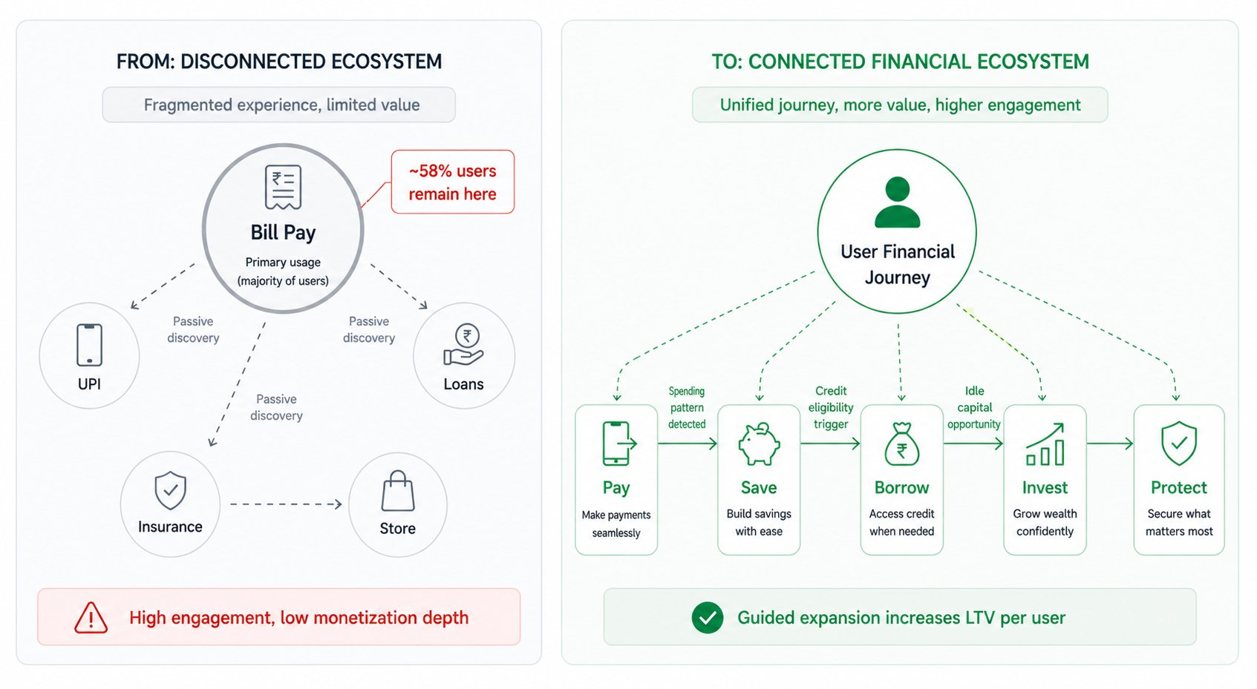
Left: ~58% of users stuck at bill-pay with passive discovery. Right: unified lifecycle journey with guided expansion increasing LTV per user.

07 / REVENUE IMPACT
What This Redesign Unlocks: ₹265 Cr – ₹865 Cr ARR
These scenarios are not aspirational — they are derived from the behavioral logic of the system changes above, applied to CRED's current numbers. The math is conservative by design.

FIGURE 05 · REVENUE POTENTIAL SCENARIOS FOR CRED
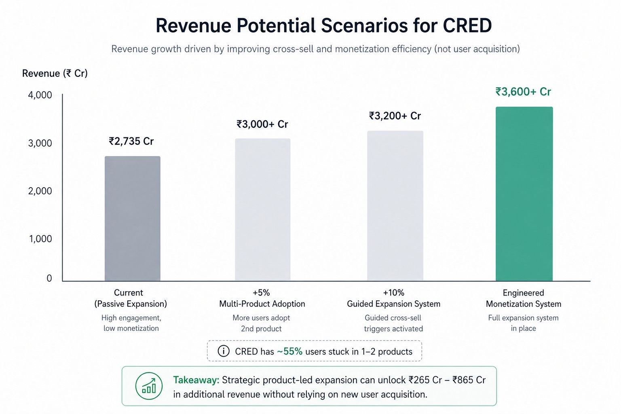
Revenue growth driven by cross-sell efficiency and monetization system redesign — not new user acquisition.

Scenario | ARPU Uplift | Multi-Product Shift | Incremental Revenue
Conservative | +8–12% | +5% users to 3+ products | ₹200–350 Cr/year
Moderate | +15–20% | +10% users to 3+ products | ₹400–550 Cr/year
Aggressive | +25–35% | Full expansion system live | ₹700–950 Cr/year

The logic is straightforward and the numbers are conservative. Multi-product users generate 1.5–2x ARPU compared to single-product users. CRED currently has 55% of its active base on 1–2 products. A 5-point shift in that ratio — from 45% to 50% on 3+ products — unlocks ₹80–130 Cr in incremental annual revenue without a single new user acquired.

Contextual monetization triggers add a second layer: improving conversion timing at high-intent behavioral moments by even 10–20% generates ₹130–220 Cr/year. Combined with the unified financial journey increasing product adoption rates across the existing base, the system redesign has the potential to unlock ₹265 Cr–₹865 Cr in additional annual revenue — entirely from the user base CRED already has.

Directional estimates based on modeled scenarios using publicly available CRED financials, user behavior data, and industry benchmarks. Actual impact dependent on execution, product adoption curves, and market conditions.

08 / CLOSING INSIGHT
CRED Does Not Need More Users. It Needs to Monetize the Ones It Has.
This is not a growth problem.
CRED's user pool is deliberately constrained — the CIBIL threshold is not a bug, it is the product's entire value proposition. Chasing volume at the cost of user quality would destroy the platform's primary competitive moat.
Every week without an engagement-to-monetization conversion layer, CRED leaves revenue in accounts that are already engaged, already qualified, and already returning.
CRED's next ₹865 Cr will not come from more users. It will come from better monetizing the 13 million it already has — and the architecture to do it is entirely within reach.

The users are premium. The products exist. The engagement is among the strongest in Indian fintech. What is absent is the layer that connects them — the automated, contextual, behavior-triggered system that converts what users do into what CRED earns.

That is not a product change. It is a revenue architecture change. The distinction matters: product changes take years and introduce risk. Architecture changes are surgical, measurable, and compound from day one.

The opportunity is not to build something new. It is to connect what already exists — and capture the value that has been accumulating, untouched, since CRED's first engaged user paid their first bill.

If your product is generating engagement but not converting it into revenue —
this is the problem we solve.

Reach out to discuss a revenue architecture engagement tailored to your product, user base, and monetization model.

