REVENUE TEARDOWN
· EXPANSION STRATEGY ·
2025-26

SUBJECT·HUBSPOT INC.
HUBSPOT
$300M
PROBLEM
How a $3.1B ARR company is leaving its most powerful growth lever untouched

DOCUMENT TYPE | Strategic Case Study — Consulting Grade
SCOPE | Expansion Monetization Redesign
CORE THESIS | HubSpot's expansion engine is structurally passive — usage signals do not automatically convert to revenue
ESTIMATED OPPORTUNITY | $150M – $300M+ Incremental ARR from Existing Accounts

CASE STUDY · PORTFOLIO ASSET ·

01 / EXECUTIVE SUMMARY
Built for Adoption. Not Built for Monetization.
HubSpot has engineered one of the most effective product-led growth systems in enterprise SaaS. Its freemium CRM captures demand at scale. Its content flywheel drives organic discovery. Its platform breadth creates genuine switching costs.

None of that is the problem.

The problem sits one layer deeper: HubSpot's expansion engine — its single highest-leverage revenue mechanism — is structurally passive. Usage grows. Dependency deepens. Signals accumulate. Nothing happens automatically. Expansion waits for a sales rep, a renewal conversation, or user initiative.

On a $3.1B ARR base, that is not a growth problem. It is a revenue architecture problem — and it is compounding.

$150M–$300M+  Incremental ARR — Existing Accounts | 102–105%  Current NRR — vs. 115% Peak | 62%  New Pro+ Customers — Already Multi-Hub

02 / CORE THESIS
The Signal–Monetization Gap
HubSpot's system generates four distinct expansion signals continuously: high usage, team growth, feature depth, and cross-functional activity. Every signal is observable. Every signal maps to a concrete revenue action — upgrade, add hub, increase plan, expand account.

Between the signal and the action: nothing. No automated conversion layer. No real-time trigger. No in-product monetization logic.

This is not a data problem. HubSpot has the signals. It is an architecture problem — the system observes value creation, then waits for a human to convert it into revenue.

FIGURE 01 · SIGNAL-TO-MONETIZATION GAP
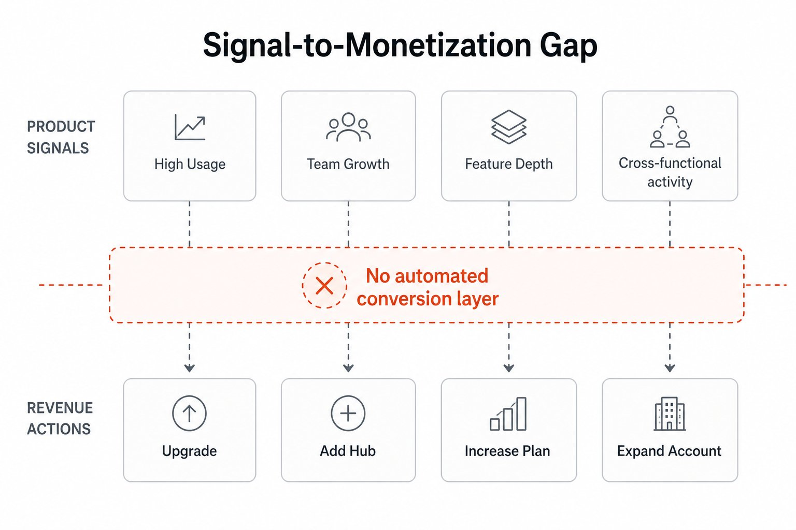
Product signals exist. Revenue actions exist. The bridge between them does not.

HubSpot has solved acquisition. It has solved activation. It has built deep product dependency. What it has not solved is automatic monetization — the real-time conversion of value created into revenue captured.

03 / SYSTEM BREAKDOWN
How the Engine Works — And Where It Stops
The architecture is deliberate and largely effective — through activation. The failure is precise: the system stalls at the expansion stage, exactly where the revenue opportunity is highest.

Acquisition — Volume Without Monetization Pressure
The free CRM captures demand at scale. Unlimited contacts. Immediate usability. Strong standalone value. This is correct by design — the free layer exists to embed usage, not to monetize. It succeeds completely at that objective. This creates a compounding problem: users arrive trained to expect value without payment.
Activation — Constraint-Triggered, Not Value-Triggered
Users reach initial value quickly. The only upgrade pressure comes from hard limits — two-seat cap, no workflows. This forces a reactive upgrade driven by constraint, not realized value. This leads to a foundational issue: the first monetization moment trains users to associate payment with restriction removal, not capability expansion. Average initial ARPU of ~$11,600 reflects this — single-hub, single-use-case adoption.
Usage — Deep Dependency, Siloed by Design
Paid teams build genuine operational dependency — campaigns, pipelines, support workflows. Usage becomes mission-critical. It also stays confined within the initial hub. There are minimal cross-hub prompts. No system logic surfaces what adjacent products would solve next. This compounds into the expansion gap: every day of siloed usage is a missed expansion event.
Expansion — High Potential, Architecture Doesn't Match
About 62% of new Pro+ customers arrived multi-hub in 2025. Among existing customers, ~40% of ARR comes from accounts with four or more hubs. Multi-hub customers generate materially higher ACV. The expansion signal is unambiguous — and it is generating zero automated response.

HubSpot's own investment in an AI cross-sell tool for sales reps confirms the structural gap: expansion requires human intervention because the product does not trigger it automatically.

FIGURE 02 · CURRENT VS. OPTIMIZED REVENUE FUNNEL
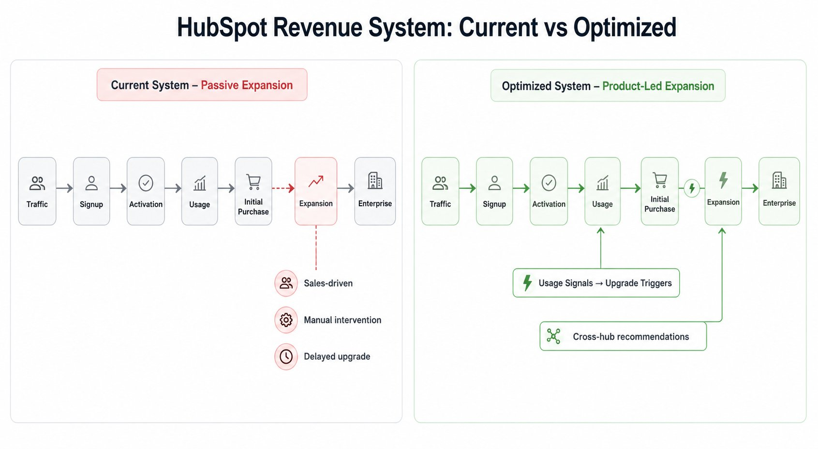
Current system: expansion depends on sales intervention. Optimized system: usage signals drive automatic expansion triggers.

04 / REVENUE LEAKS
Four Leak Points. One Root Cause.
The failures are not isolated. Each traces back to the same structural absence: a system that observes value creation but does not act on it.

FIGURE 03 · REVENUE LEAK MAP
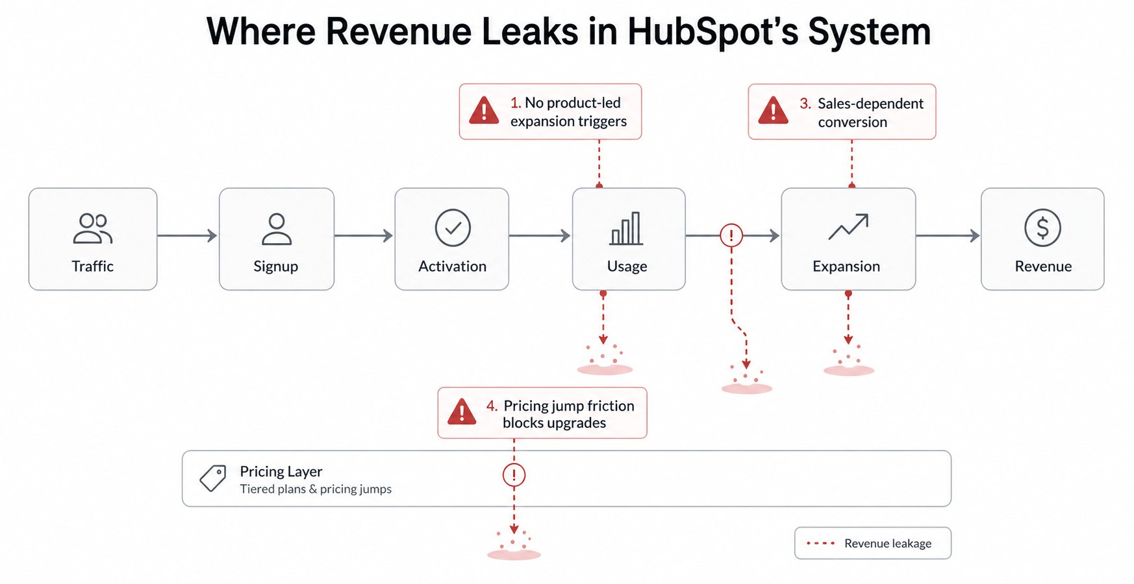
Four discrete leak points across the funnel — each rooted in the absence of product-led expansion logic.

01 | No Product-Led Expansion Engine  Heavy campaign volume generates no Marketing Pro prompt. Growing teams trigger no dynamic hub suggestion.  The product watches. It does not act.  HubSpot runs a product-led acquisition model on top of a sales-led expansion model. That structural contradiction creates a compounding gap: high product usage does not automatically produce revenue expansion.  Revenue impact: a 5–10% shift toward product-driven expansion unlocks $100M+ ARR through ARPU lift and NRR improvement.

02 | Expansion Depends on Human Intervention  Growth beyond the initial hub is not systemized. It is triggered during renewals, account reviews, or partner check-ins.  NRR has stabilized at 102–105%, down from ~115% in 2021. That compression is the direct financial signature of this failure — expansion is slowing relative to usage depth.  A scalable SaaS revenue system converts usage into revenue without requiring human intervention at every step. HubSpot's current model inverts this.  Revenue impact: every quarter without automated expansion logic is a quarter of compounding NRR degradation.

03 | Pricing Architecture Blocks Incremental Expansion  Starter-to-Pro jumps are non-linear. Hub additions are all-or-nothing decisions. Individual features are gated behind full-tier purchases — forcing workarounds over upgrades.  Customers are behaviorally willing to expand gradually. The pricing architecture forces episodic, high-commitment decisions. This creates stalled accounts: high usage, flat revenue, no proportionate pathway forward.  Revenue impact: mid-tier accounts that should micro-expand systematically stay flat. The pricing structure actively suppresses expansion velocity.

04 | Signals Accumulate — Then Expire  Usage data is rich. Product signals are real. The system does not translate observed behavior into monetization actions in real time.  In a high-performing expansion system, every high-value signal triggers a monetization action automatically. In HubSpot's system, signals inform a sales meeting — eventually, inconsistently, only when someone is paying attention.  Revenue impact: slower expansion cycles, lower conversion from usage to revenue, permanent suppression of the compounding effect across the customer base.

05 / STRUCTURAL PROBLEM
One Failure. Four Symptoms.
The four leaks are not independent problems. They are four expressions of a single architectural failure: the absence of an automated Signal → Monetization conversion layer.

HubSpot's expansion engine is passive by design. The system generates value continuously. It captures revenue inconsistently. The gap between the two is not a product gap or a demand gap — it is a revenue architecture gap.

Every high-value usage behavior — campaign volume, team growth, feature depth, cross-functional activity — is a monetization signal. In the current system, these signals arrive, accumulate, and wait for a human to act. In a well-architected revenue system, they trigger automatic, contextual, in-product monetization actions.

That layer does not exist in HubSpot today.

A product that generates signals but not revenue from them is a reporting tool with a pricing page attached.
The highest-leverage growth in HubSpot's system already exists — inside accounts, inside usage patterns, inside signals that fire every day. It is simply not being captured.

06 / STRATEGIC RE-ARCHITECTURE
Five System-Level Fixes
These are not feature requests or marketing campaigns. They are structural changes to how HubSpot converts usage into revenue — each targeting a discrete failure in the current architecture.

01 Build a Signal-to-Action Expansion Engine
SIGNAL | Account crosses defined usage thresholds: campaign send volume, pipeline stage complexity, cross-functional page access, team seat growth.
TRIGGER | Usage scoring engine detects threshold breach in real time. Score is evaluated against account tier and current hub composition.
ACTION | In-product contextual prompt surfaces — framed to realized value, not restriction. High campaign volume → Marketing Pro upgrade. Pipeline complexity → Sales Hub expansion. Support interactions → Service Hub introduction. No sales rep required.
OUTCOME | Automated expansion replaces the sales-intervention model for mid-tier accounts. Expansion velocity increases. NRR compounds quarterly without headcount growth.

02 Shift to Lifecycle-Based Monetization
SIGNAL | User behavior maps to a customer lifecycle stage — lead generation, conversion, retention, or scaling — not just a product hub.
TRIGGER | System detects lifecycle stage transition: usage patterns indicate a team moving from lead gen into active pipeline management.
ACTION | Expansion offer surfaces as a natural lifecycle continuation — 'Your team is converting at scale. Here's what the next stage looks like.' Adjacent hub value is positioned as a workflow extension, not a separate product purchase.
OUTCOME | Removes artificial product boundaries from the expansion decision. Makes each upgrade feel proportionate and inevitable — not like a separate procurement event.

03 Redesign Pricing for Incremental Expansion
SIGNAL | Account is using 70–90% of a feature's capacity, or repeatedly encountering feature gates without upgrade action.
TRIGGER | System flags the account as a 'stalled expander' — willingness is present, the pricing commitment is the barrier.
ACTION | Modular unlock options surface: gradual feature access, flexible add-ons, usage-based components for contacts, automation runs, and seats. The decision is sized to the need, not to the full tier.
OUTCOME | Converts stalled accounts into active expanders. Every proportionate expansion decision becomes a revenue event. Mid-tier ARPU increases without requiring customers to make large, low-confidence commitments.

04 Embed Expansion Pathways into Core Product Experience
SIGNAL | User completes a high-value workflow action that has a direct adjacent capability — e.g., sends a campaign sequence, closes a pipeline deal, resolves a support ticket at volume.
TRIGGER | System detects workflow completion and evaluates adjacency map — which neighboring hub or feature extends the value just realized.
ACTION | In-product guided pathway appears: embedded cross-hub visibility, trial exposure to adjacent hubs, one-click expansion option. The decision happens inside the product, not on a pricing page visited separately.
OUTCOME | Expansion becomes a continuation of product usage — not a separate commercial decision. Conversion rate from usage signal to revenue event increases materially.

05 Unify Product, Sales, and Data into a Revenue Architecture Layer
SIGNAL | Product data identifies high-value expansion signals across the account base. Sales team has no systematic visibility into which accounts are signaling and when.
TRIGGER | A unified expansion layer aggregates product signals, scores accounts by expansion readiness, and routes them: automatic monetization for low/mid-tier, prioritized sales queue for high-value or complex expansions.
ACTION | Low and mid-tier expansion happens automatically via in-product triggers. High-value expansions surface to sales with full signal context — account score, usage pattern, recommended next hub, optimal timing.
OUTCOME | Every account is actively expanding — not just the ones a sales rep happened to call. NRR becomes a managed, predictable metric rather than a lagging indicator.

FIGURE 04 · EXPANSION MODEL: PASSIVE VS. PRODUCT-LED
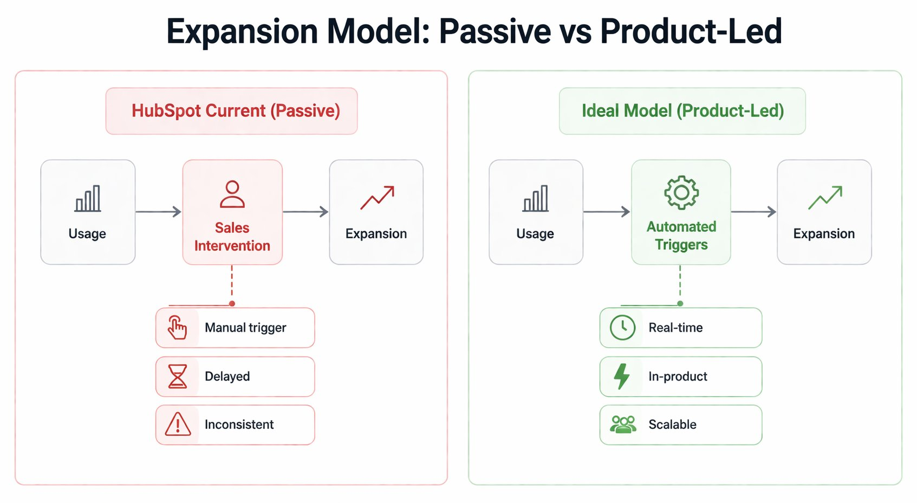
Current model: sales intervention required for every expansion event. Ideal model: automated triggers convert usage signals into revenue actions in real time.

FIGURE 05 · PRICING VS. VALUE PROGRESSION
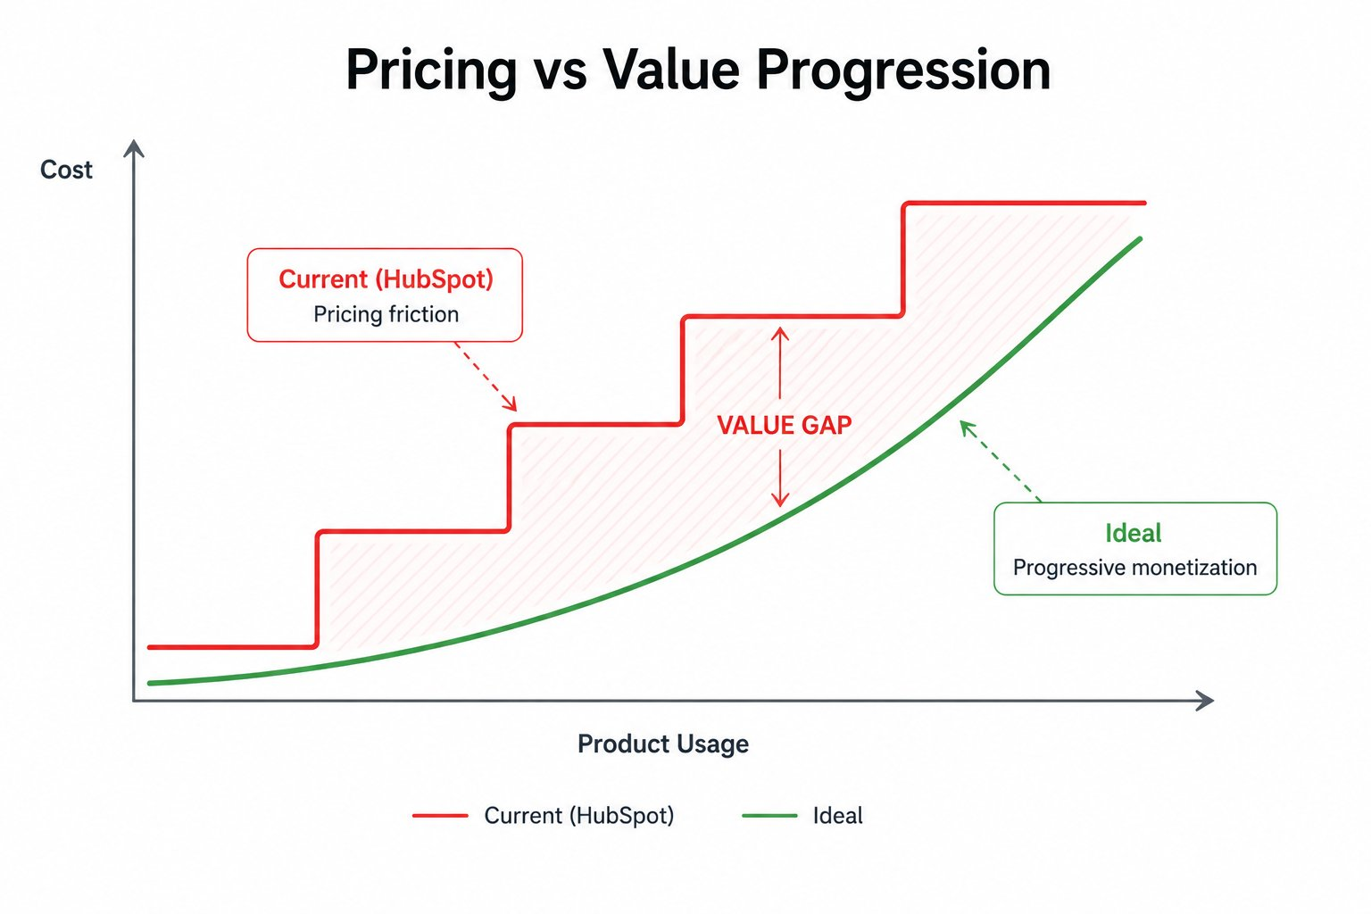
Current pricing: step-function jumps that create hesitation and workarounds. Ideal model: progressive monetization that scales continuously with product usage.

07 / REVENUE IMPACT
What This Unlocks: $150M–$300M+ ARR
The opportunity is not theoretical. It is embedded in the existing customer base — already generating signals, already demonstrating the usage patterns that precede expansion. The system is simply not designed to capture it.

SCENARIO 1  Multi-Hub Adoption +5–10%  Shifting 5–10% of single-hub accounts to dual-hub — at an average ARPU differential of ~$7K — generates $100M–$200M+ ARR uplift directly. Without acquiring a single new customer. | SCENARIO 2  Faster Expansion Cycles  Real-time product triggers shorten time-to-expansion. Higher conversion from usage to revenue. Stronger compounding quarterly effect on new ARR — each cycle faster than the last. | SCENARIO 3  NRR from 102–105% → 107–110%  Systemized expansion adds 2–5% compounding annual growth on the existing ARR base. At $3.1B ARR, each percentage point of NRR improvement is worth $30M+ annually.

When these three vectors compound — higher ARPU, faster cycles, improved retention — the effect is not additive. It is multiplicative. Each improvement reinforces the others. This is how platform businesses scale non-linearly.

Directional estimates based on modeled scenarios using publicly disclosed financials, pricing structure, and multi-hub adoption data.

08 / CLOSING INSIGHT
The Growth Already Exists. The System Isn't Built to Capture It.
This is not a growth problem.
HubSpot does not need a new product, a new market, or a new demand generation strategy.
It needs a revenue system that treats expansion as a product responsibility — not a sales responsibility.
Every week without an automated signal-to-monetization layer, HubSpot leaves expansion revenue in accounts that are already signaling readiness.

The usage is there. The dependency is there. The willingness to pay is demonstrably there — 62% of new customers already prove it by arriving multi-hub. The missing element is not demand. It is the architecture to capture it.

That architecture is buildable. The signals already exist. The revenue actions already exist. The gap between them is the only thing that needs to change.

If your product is generating signals but not revenue from them —
this is the problem we solve.

Reach out to discuss a revenue architecture engagement — tailored to your product stage, customer base, and expansion model.

