REVENUE STRATEGY
· MONETIZATION TEARDOWN · 2025-26

SUBJECT·NOTION INC.
REVENUE
ARCHITECTURE
Monetization Teardown — Why $100M+ Is Left on the Table

DOCUMENT TYPE | Strategic Case Study — Portfolio Asset
SCOPE | Monetization Architecture Redesign
CORE THESIS | Value creation and revenue capture are structurally decoupled.
ESTIMATED OPPORTUNITY | $95M – $135M ARR — Without New Users or New Products

CASE STUDY · PORTFOLIO ASSET ·

00 / EXECUTIVE SUMMARY
The Case in Two Sentences
Notion has built one of the most effective product-led growth engines in SaaS. It has not built a revenue architecture to match.

The free tier is exceptional. Viral team adoption is real. Dependency compounds at every stage. And yet: upgrades are friction-triggered, not value-aligned. The result is a structural gap — not a growth gap — between what Notion delivers and what it captures.

The gap between value delivered and revenue captured represents an estimated $95M–$135M in annual recurring revenue — accessible without new product lines, without a single new user.

$95M–$135M  Modeled ARR Opportunity | ~87–95%  Free Users — Unpaid Today | 5,000+  Mid-Market Teams Undermonetized

01 / CORE INSIGHT
Value Compounds. Revenue Doesn't Follow.
Notion's value delivery is front-loaded and accelerating. Users build deep dependencies—personal workflows, team knowledge bases, operational systems — long before any monetization moment arrives. By the time a payment is triggered, it is driven by friction, not gratitude.

This is not a design accident. It is a structural misalignment: the gap between what users receive and what Notion captures widens at every stage of the journey.

FIGURE 01 · VALUE VS. REVENUE CURVE
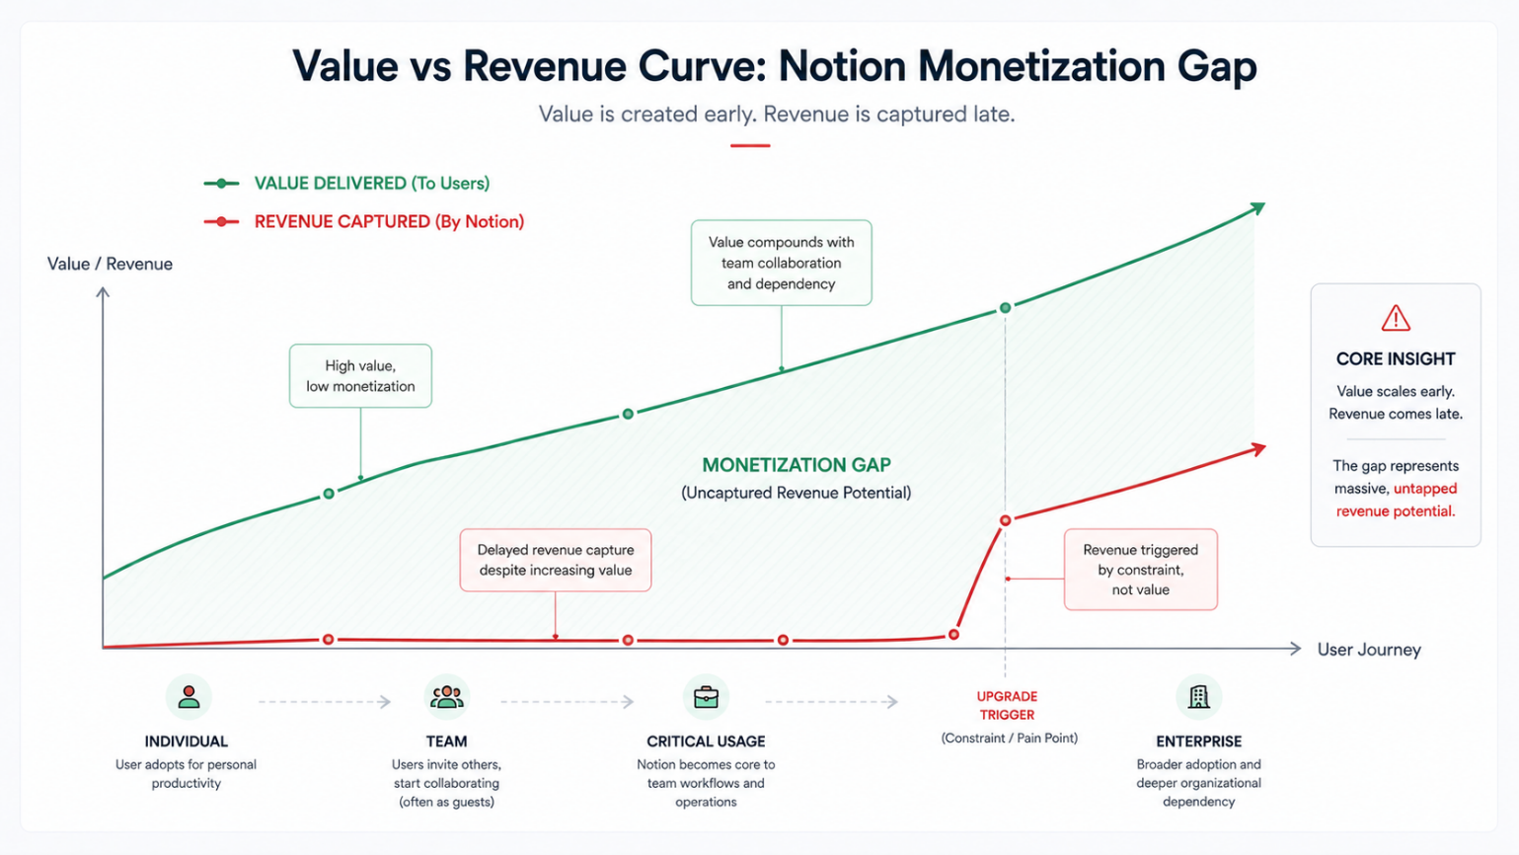
Value created early, compounding with team dependency. Revenue captured late — triggered by constraint, not realization.

The monetization gap is not the result of weak marketing or poor product quality. It is the result of revenue architecture that fires too late. Every stage of the user journey creates value. Almost none of it is captured in real time.

02 / PROBLEM BREAKDOWN
The System Failure Across Four Stages
The monetization failure is not a single point of weakness. It is a cascading misalignment across every stage of the user journey. Each stage creates compounding value. Each stage fails to capture it.

01 | Individual Usage — High value. Zero monetization.  Users build full operating systems in Notion — notes, projects, databases, and second brains. The free tier is effectively unlimited for solo use. Engagement is deep. Revenue pressure is nonexistent. Notion funds this stage entirely through goodwill.

02 | Team Formation — Collaboration scales. Revenue doesn't.  As teams form organically — sharing pages, building shared wikis — Notion's viral loop activates. New members join free. Workflows deepen. The workspace becomes mission-critical. Revenue remains flat. Guests don't pay for seats.

03 | Critical Usage — Dependency is built. Upgrade trigger is wrong.  Notion is now embedded in daily operations — project tracking, documentation, and meeting notes. Teams rely on it. Yet the upgrade signal is a friction wall: hit a guest limit, hit a file cap. Users feel locked out, not invited to invest. Churn risk spikes.

04 | Enterprise Conversion — Delayed, friction-heavy, sales-gated.  High-usage organizations that should be Enterprise customers sit on Plus or free plans awaiting a sales conversation about SSO or compliance. The pathway is slow, manual, and fundamentally mismatched to how these teams already operate Notion.

03 / DIAGNOSTIC
Revenue Leak Map: Where the Money Disappears
This is not a growth problem. The traffic flows. The activations happen. The usage deepens. What the map below reveals is that at each transition point in the user journey, Notion's system fails to convert compounding value into revenue.

FIGURE 02 · REVENUE LEAK MAP
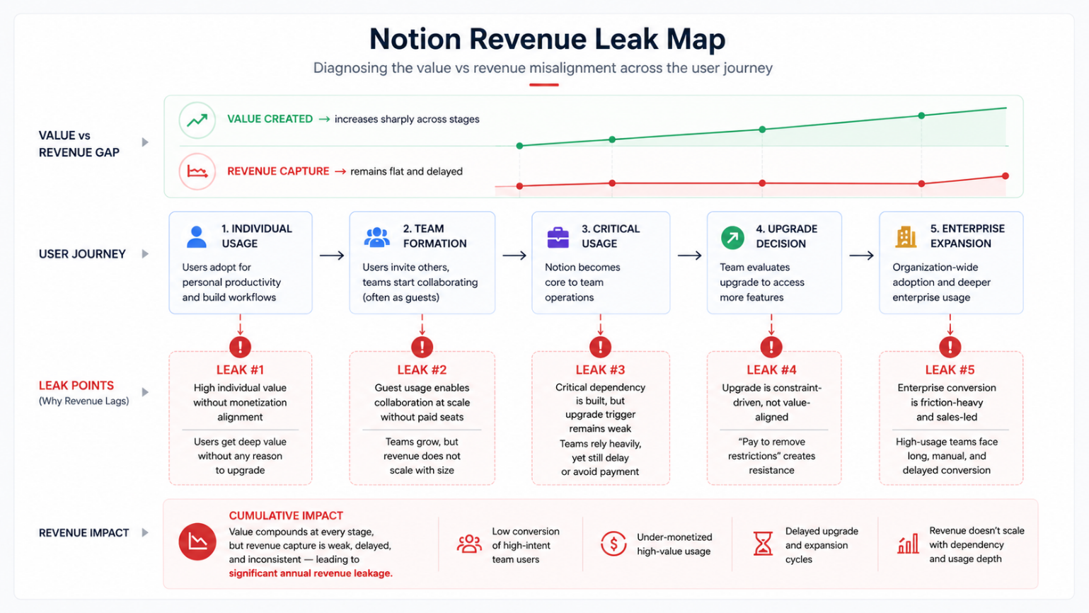

Five discrete leak points across the journey. At each stage, value compounds — revenue capture remains flat and delayed.

# | STAGE | SYSTEM FAILURE | REVENUE CONSEQUENCE
#1 | Individual Usage | High individual value, zero monetization signal. Users extract maximum value with zero conversion pressure. | Revenue is funded entirely through goodwill — no event triggers willingness to pay.
#2 | Team Formation | Guest model enables collaboration at scale — across teams and companies — without triggering seat-based revenue. | Team growth multiplies value delivered while revenue stays flat.
#3 | Critical Usage | Dependency is established. Teams rely on Notion daily. Upgrade trigger remains constraint-based, not value-based. | The moment of maximum willingness to pay is bypassed entirely.
#4 | Upgrade Decision | The upgrade moment is framed as 'pay to remove restrictions' — generating resistance, resentment, and delay. | Conversion rates suffer. Churn risk spikes. Revenue becomes spiky and unpredictable.
#5 | Enterprise Expansion | Sales-led, friction-heavy, late. High-value organizations wait months in the wrong tier. | Enterprise revenue delayed by 3–6+ months per account. NRR is permanently suppressed.

The problem is not growth — it is misaligned monetization timing.

04 / SYSTEM MISALIGNMENT
Current Funnel vs. What It Should Look Like
The current funnel is not broken at the top. Discovery, sign-up, and activation work. The break is in the middle — where team value compounds but the system has no mechanism to translate that value into a revenue event.

The improved model inserts two critical layers: a value recognition layer that detects usage signals before constraint walls are hit, and structured upgrade paths aligned to team growth stage. The result is a revenue architecture that scales with dependency — not against it.

FIGURE 03 · REVENUE FUNNEL: CURRENT VS. IMPROVED
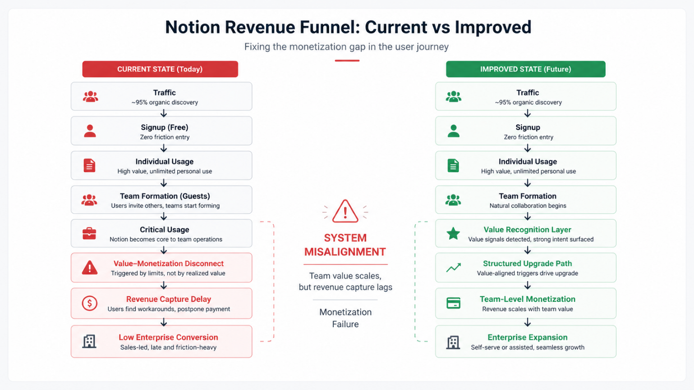
Current state: monetization fires at constraints. Improved state: monetization fires at value realization.

04B / BEHAVIORAL INSIGHT LAYER
Behavioural Misalignment: Why Users Resist Paying
Before any structural fix lands, this must be understood: the resistance is not to payment. It is to payment at the wrong moment, framed in the wrong way.

CURRENT SYSTEM  Pain-Driven Upgrades  Constraint hits → user feels frustrated → upgrade is presented as the exit from pain → decision is made under duress.  Result: resistance, resentment, delay, churn. | REQUIRED SYSTEM  Value-Driven Upgrades  Progress milestone reached → system surfaces upgrade as recognition of what's already working → decision is made from confidence, not pressure.  Result: willingness, trust, expansion.

Users don't resist paying — they resist paying at the wrong moment. The problem is not pricing. It is timing and framing.

This single insight reframes the entire monetization challenge. It moves the solution space from pricing strategy to product architecture — specifically, to the question of when and how upgrade moments are surfaced. The fixes that follow are built on this foundation.

05 / STRATEGIC RECOMMENDATIONS
Five System-Level Fixes
These are not feature requests. They are structural changes to how revenue is triggered, timed, and captured. Each fix targets a specific failure mode identified in the diagnostic. Each is implementable as a discrete product decision.

01 | Value Recognition Layer  TRIGGER A user has created 3+ interconnected databases, invited 2+ collaborators, or accessed a page 5+ days in a row within a 30-day window.  MECHANISM A behavioural scoring engine tracks collaboration depth, page dependency rate, and cross-team page access. When a composite score crosses a defined threshold, a value milestone is surfaced — not a paywall.  USER EXPERIENCE BEFORE: User hits a guest limit, feels blocked, delays or avoids upgrade. AFTER: User receives an in-product moment — 'Your team has built something powerful. Here's what Plus unlocks for teams like yours.' Upgrade is framed as recognition, not restriction.  REVENUE EFFECT Converts the highest-intent, highest-value cohort before churn risk activates. Estimated 15–25% lift in Plus conversion from active free users.

02 | Team-Level Monetization  TRIGGER A workspace reaches 3+ active members collaborating on shared pages within a 14-day period.  MECHANISM A lightweight Team plan activates automatically in the UI — not as a forced gate, but as a contextual offer tied to team activity. Pricing reflects team size, not arbitrary seat caps.  USER EXPERIENCE BEFORE: Teams grow organically on free tier. No monetization signal, no upgrade path visible. AFTER: Team formation itself becomes a monetization event. Offer appears as the team is experiencing peak value — 'You're building something together. Get the infrastructure to match.'  REVENUE EFFECT Unlocks revenue at the point of maximum engagement. Converts organic virality — currently free — into a revenue multiplier.

03 | Progressive Upgrade Triggers  TRIGGER User is within 80% of any usage threshold — guest count, page history, file attachment size.  MECHANISM Instead of a hard wall, the system surfaces a gradient prompt: a value-framed nudge that shows what's possible, not what's blocked. The prompt appears proactively — before frustration, while the user is in flow.  USER EXPERIENCE BEFORE: 'You've reached your guest limit. Upgrade to add more.' AFTER: 'Your team is growing fast. See what Plus teams accomplish with unlimited guests and advanced permissions.' Limitation is contextualized as an opportunity.  REVENUE EFFECT Eliminates the friction spike at the constraint boundary. Reduces churn-driven urgency. Increases upgrade rates by converting decision from defensive to aspirational.

04 | Self-Serve Enterprise Pathway  TRIGGER A workspace has 10+ members, uses SSO-eligible email domains, or has a team admin who has searched for SSO/compliance settings.  MECHANISM An 'Enterprise Lite' tier — covering SSO, basic audit logs, and domain management — becomes available via in-product self-serve. No sales call required for initial activation. Sales is reserved for expansion above a defined seat threshold.  USER EXPERIENCE BEFORE: IT admin identifies compliance need, submits inquiry, waits for sales outreach, begins negotiation. Time to revenue: 60–120 days. AFTER: Admin activates Enterprise Lite in 15 minutes. Sales engages post-activation for expansion. Time to revenue: same day.  REVENUE EFFECT Eliminates the single largest bottleneck in enterprise conversion. Captures the 10–100 seat segment — the fastest-growing enterprise entry point — without sales cost.

05 | Expansion Revenue Alignment  TRIGGER A new member joins an existing paid workspace, a new teamspace is created, or a workflow expands to involve a department that was previously free.  MECHANISM An automated seat-expansion loop surfaces contextual upgrade prompts tied to growth events. The system detects when a paid workspace is growing and routes the admin toward expansion — before usage creates friction.  USER EXPERIENCE BEFORE: Admin manually realizes they need more seats, logs in to billing, adjusts. Expansion is manual, delayed, and often skipped. AFTER: 'Your team just added 3 new members. Your plan covers them — here's what changes at the next tier.' Expansion is a natural continuation of growth.  REVENUE EFFECT Transforms NRR from a lagging metric to a proactive mechanism. Seat expansion becomes automatic. Revenue scales with team dependency, not against it.

06 / TIMING SHIFT
Upgrade Trigger Flow: Before vs. After
The current model is sequential and reactive: usage grows, dependency deepens, constraint hits, upgrade happens — reluctantly. The user experience is paying to get unblocked. The revenue profile is spiky, unpredictable, and churn-correlated.

The realigned model intercepts at the value milestone. When a team crosses a collaboration threshold, the system surfaces upgrade framing tied to that team's realized value — before any wall is hit. The user experience shifts from paying to escape to investing in what's already working.

FIGURE 04 · UPGRADE TRIGGER FLOW: DELAYED VS. ALIGNED
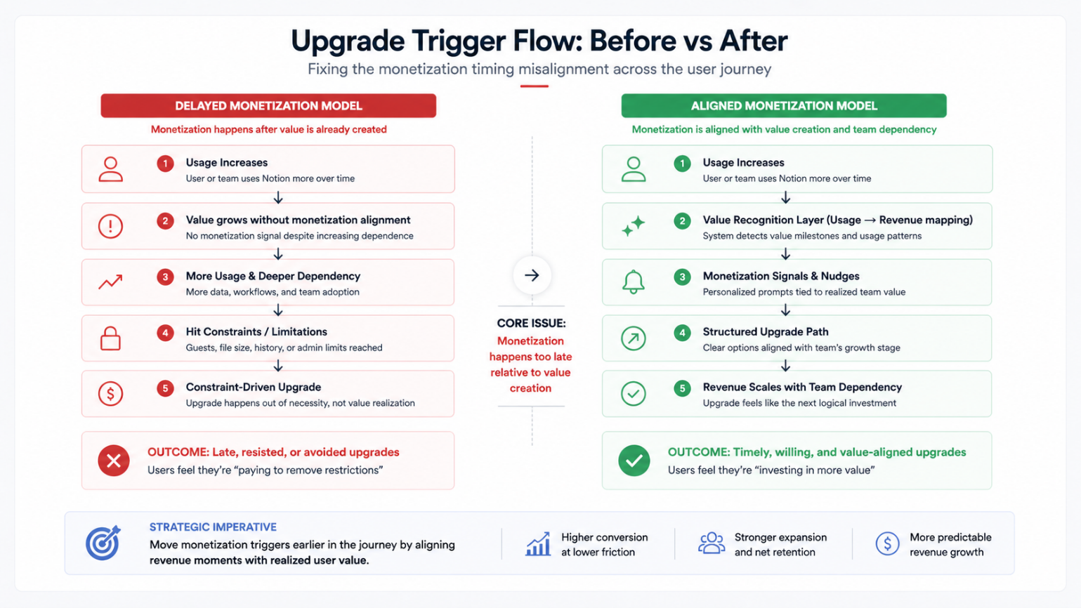
Left: monetization happens after value is already delivered — generating resistance. Right: monetization is aligned to value realization — generating willingness.

BEFORE  - Upgrade triggered by constraint  - Users feel blocked, not invested  - Late, resisted, or avoided upgrades  - Revenue is spiky and unpredictable | AFTER  - Upgrade triggered by value milestone  - Users feel they're investing in growth  - Timely, willing, value-aligned upgrades  - Revenue scales with team dependency

07 / REVENUE IMPACT
The Opportunity: $95M–$135M ARR
LAYER 1 · STRATEGIC FRAMING
This is not incremental optimization.
This is a structural revenue unlock.

LAYER 2 · QUANTIFIED MODEL

The following estimates are based on modeled scenarios using publicly available pricing and usage data. Assumptions are stated explicitly:

Assumption | Basis
5,000 mid-market teams, avg. 50 seats | Conservative estimate based on public Notion user base disclosures and PLG conversion benchmarks
Upgrade: $15 → $20/user/mo | Modest per-seat step reflecting mid-market tier pricing architecture
Incremental ARR from this cohort alone | $5M+ — without acquiring a single new user
Mid-market self-serve unlock | ~50% of Fortune 500 already use Notion; millions more on cheaper plans due to procedural friction alone
Constraint → value trigger conversion lift | 15–30% conversion improvement modeled on comparable PLG companies that realigned upgrade framing

LAYER 3 · EXPANSION MULTIPLIER

The $95M–$135M model is conservative. The true ceiling is higher — because the underlying system fixes are compounding and cross-segment:

FREE USER BASE  87–95% of users pay nothing today. Value recognition triggers convert this cohort without acquiring anyone new. Even a 2% shift moves the needle at scale. | MID-MARKET UPGRADE  5,000+ teams on the wrong plan due to friction, not intent. Self-serve enterprise and progressive triggers convert this segment faster than any sales motion. | ENTERPRISE EXPANSION  Expansion revenue loops tied to team growth events turn NRR from a lagging metric into an automated compounding mechanism.

08 / CONCLUSION
The System That Captures the Value
The diagnosis is unambiguous. Notion has an exceptional product, a massive user base, and compounding team dependency. What it does not have is a revenue architecture calibrated to capture value at the moment it is realized.

Fixing this is not a pricing exercise. It is not a growth campaign. It is a revenue systems redesign — triggers, timing, pathways, and framing, all realigned to how teams actually grow inside Notion.

Notion has already built the value.
It just hasn't built the system to capture it.

The users are there. The usage is there. The dependency is there. The $95M–$135M gap does not require a new product, a new market, or a new pricing model. It requires revenue architecture that fires at the moment of value — not months later, under duress, through a sales call.

If your product is scaling usage but not revenue —
this is exactly the kind of problem we solve.

Reach out to discuss a revenue architecture engagement tailored to your product, users, and growth stage.

